Revision History
Date | Version | Description | Author
27/12/2021 | 1.0 | Started and finished the first draft of the entire report | Alanur Bilgili  Damla Tütüncü  Görkem Öçmen  Gufran Yeşilyurt  Kaan Yılmaz  Murat Can Altun
28/12/2021 | 1.1 | Changed the data to match the changed code | Murat Can Altun

TABLE OF CONTENTS
Revision History 1
1 Introduction 3
1.1 Document overview 3
2 Static Code Analysis 4
2.1 Tools 4
2.2 Results and Discussion 4
3 Dependency Analysis 5
3.1 Tools 5
3.2 Results and Discussion 5
4 Test Coverage Analysis 7
4.1 Tools 7
4.2 Results and Discussion 7

Introduction

Document overview
This document presents and interprets the code analysis results regarding the PAMA software development project. Code is analyzed by 3 different tools: 1) Static Code Analysis tool 2) Dependency Analysis tool and 3) Test Coverage tool. The first tool is used to reveal potential bugs that might be overseen during the testing process. The second tool is employed for evaluating the design quality based on the amount of coupling among the software modules and to what extent the code reflects the originally envisioned design. The last tool is used for measuring the coverage of unit tests in the project. Each section below is dedicated to each of these 3 analyses.

Static Code Analysis

Tools
We used PMD v6.21.0 (with QAPlug plugin) to do the analysis. It looks for bugs in Java code within Intellij IDEA.

Results and Discussion
- The QAPlug-PMD plugin found 95 bugs in the code.
- 69 of the bugs were minor while 26 of them were major.
- The major bugs were related to unused code and coupling.
- None of the bugs caused a system crash/build error.

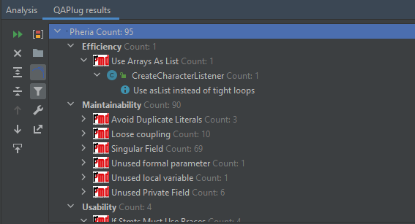

Analysis of alerts that are reported by the tool:

Type | Count of Instances | Severity | Count of Real Bugs
Efficiency | 1 | Major | 0
Maintainability | 90 | Minor | 0
Usability | 4 | Major | 0

Dependency Analysis

Tools
IntelliJ IDEA Dependency Diagram tool is used to do dependency analysis in our project.

Results and Discussion
Dependency Graph for PAMA is as follows
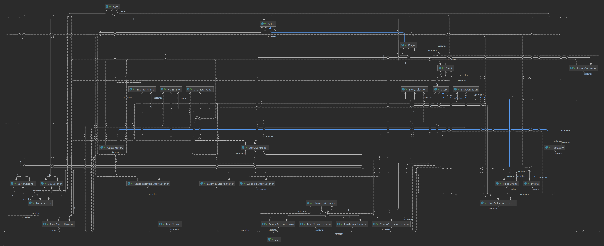

The extracted dependency graph is presented above. Calculated set of metrics based on this graph is listed below:

# of Edges = 113
# of Nodes = 31
Edge-to-node Ratio = 113 / 31 = 3.65
Tree Impurity = 2 * (113 – 31 + 1) / (31 – 1) * (31 – 2) = 166 / 870 = 0.19

We have seen that the tree impurity turned out to be quite small. That can be an indication for a good design structure. But the edge-to-node ratio is high. On the other hand, we can see that some of the modules are highly coupled with the other modules. For instance, the module StoryController is highly coupled as most of the edges are associated with this module. However, since we designed PAMA to run with StoryController at its heart, it was expected. This module can be refactored and possibly decomposed into several modules to reduce dense coupling at this single module.

Test Coverage Analysis

Tools
IntelliJ IDEA’s Test Coverage built-in tool is used for test coverage analysis.

Results and Discussion
Below is the overall test coverage report. The inspection shows that with the test close to 67% of the lines, 68% of methods and most of the classes are covered.

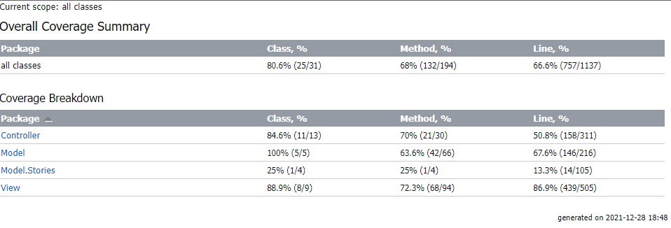

The test does not (and cannot) cover the classes that are triggered by user interaction with the interface. Since the user didn’t create his own story, methods are not covered which can be seen in the example below.

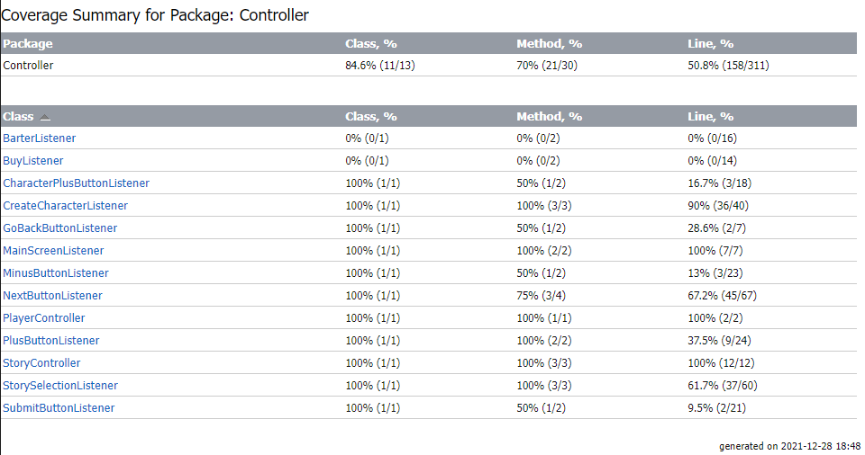

This is also the case for most of the other controller classes since they are instantiated but neither the classes nor the methods inside are not used.
MinusButtonListener is instantiated most of the time since it must be available on the character creation page. However, the minus buttons were not used by the player, decreasing the coverage rate.

